- Build a SOHO Network

Q1. Draw a network diagram for a small office/home office (SOHO) setup that includes: one broadband internet connection, one Wi-Fi router, two laptops, one smart TV, and one printer. Clearly label each device and connection type (wired or wireless)?

Answer

- SOHO Network Diagram

s
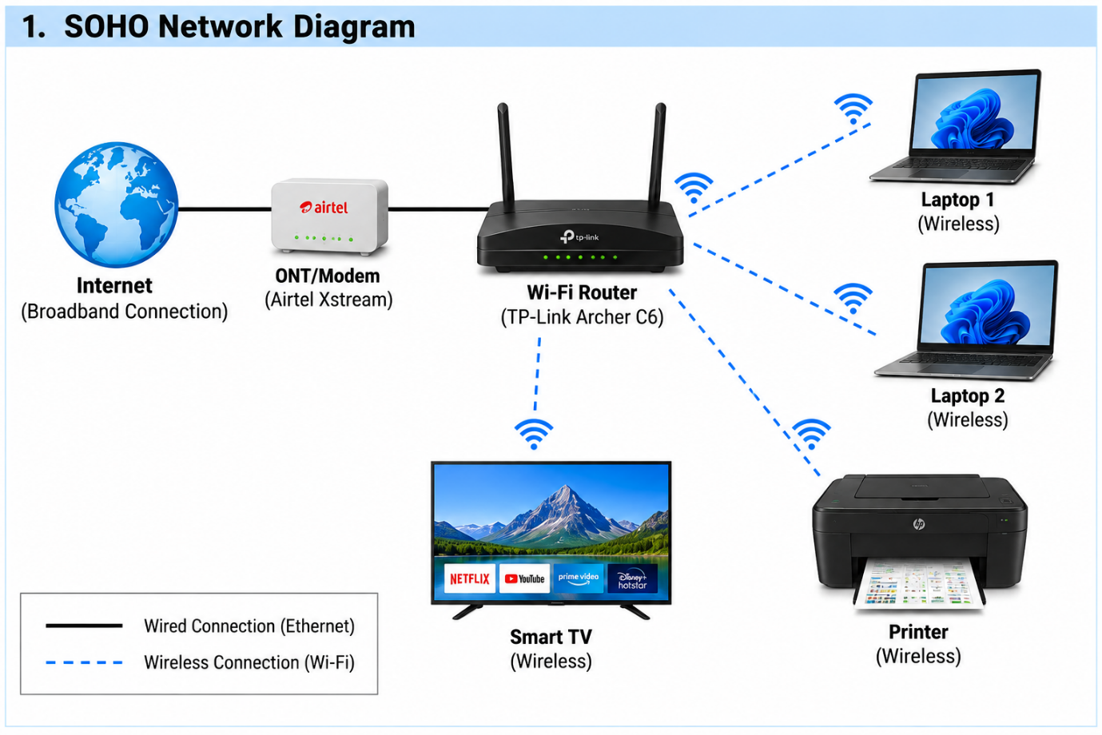

- The diagram shows a small office/home office network with one broadband internet connection connected to a Wi-Fi router. Two laptops, one smart TV, and one printer are connected to the router wirelessly using Wi-Fi.

- The broadband connection from the ISP/ONT to the router is a wired Ethernet connection, while the laptops, smart TV, and printer use wireless Wi-Fi connections.

Q2. List all the hardware components (with brand/model suggestions) you would need to physically build the SOHO network diagrammed above, including cables and any switches or extenders if needed.<br><br><em><strong>Hint:</strong> Check current listings on Flipkart or Amazon for typical device models used in Indian homes/offices.</em>?

Answer

- Hardware Components Required for the SOHO Network

Hardware Component | Brand / Model Suggestion | Purpose
- Broadband Internet / ONT | Airtel Xstream Fiber ONT or JioFiber Router/ONT | Provides the internet connection
- Wi-Fi Router | TP-Link Archer C6 AC1200 | Connects all wired and wireless devices
- Laptop 1 | HP 15 Series | Used for office/home work
- Laptop 2 | Lenovo IdeaPad Slim 3 | Second user device
- Smart TV | Samsung 43-inch Smart TV | Connects to Wi-Fi for streaming
- Printer | HP Ink Tank 415 Wi-Fi Printer | Wireless printing over the network
- Ethernet Cable | Cat6 UTP Cable | Connects the ONT/modem to the Wi-Fi router
- RJ45 Connectors | Standard Cat6 RJ45 connectors | Used with Ethernet cables
- Optional Network Switch | TP-Link TL-SG1005D 5-Port Gigabit Switch | Adds extra wired ports if required
- Optional Wi-Fi Extender | TP-Link RE305 / similar extender | Improves Wi-Fi coverage in a larger office/home

- Explanation:
These components are sufficient to build the SOHO network shown in Q1. The Wi-Fi router provides wireless connectivity to the laptops, smart TV, and printer, while a Cat6 Ethernet cable connects the broadband ONT/modem to the router. A network switch or Wi-Fi extender can be added later if more devices or better coverage are required.
Note: The model names are typical examples commonly sold in India; current availability and prices can change on Amazon or Flipkart.

Q3. Write step-by-step instructions to configure the Wi-Fi router for your SOHO network, including setting up a unique SSID, enabling WPA2 security, and changing the default admin password?

Answer

- Steps to Configure the Wi-Fi Router
- Connect the Wi-Fi router to the broadband modem/ONT using an Ethernet cable.
- Connect your laptop or phone to the router using Wi-Fi or Ethernet.
- Open a web browser and enter the router’s default IP address, such as 192.168.0.1 or 192.168.1.1.
- Log in using the default admin username and password given on the router label.
- Open the Wireless / Wi-Fi Settings section.
- Change the Wi-Fi name (SSID) to a unique name, for example: Sagar_HomeWiFi.
- Open the Wireless Security settings.
- Select WPA2-Personal (WPA2-PSK) as the security type.
- Create a strong Wi-Fi password and save the settings.
- Open the Administration / System / Management section.
- Change the router’s default admin password to a new strong password.
- Save all settings and restart the router if required.
- Reconnect your devices using the new Wi-Fi name and password.

- Result:
The Wi-Fi router is now configured with a unique SSID, WPA2 security, and a new administrator password.

Q4. Configure IP addresses for all devices in your SOHO network: assign static IPs to the printer and smart TV, and use DHCP for the laptops. Show a table listing each device, its MAC address (make one up), and the assigned IP address?

Answer

- IP Address Configuration for SOHO Network
For this network, the printer and smart TV use static IP addresses, while the two laptops receive IP addresses automatically using DHCP.

Device | MAC Address | IP Assignment | IP Address
- Wi-Fi Router | 00:1A:2B:3C:4D:01 | Static | 192.168.1.1
- Laptop 1 | 00:1A:2B:3C:4D:11 | DHCP | 192.168.1.101
- Laptop 2 | 00:1A:2B:3C:4D:12 | DHCP | 192.168.1.102
- Smart TV | 00:1A:2B:3C:4D:21 | Static | 192.168.1.20
- Printer | 00:1A:2B:3C:4D:31 | Static | 192.168.1.30

Subnet Mask: 255.255.255.0
Default Gateway: 192.168.1.1
- Explanation:
The printer and smart TV use static IP addresses so their addresses do not change. This makes them easier to find on the network. The laptops use DHCP, so the router automatically assigns their IP addresses.

Q5. Explain how you would troubleshoot if one of the laptops cannot connect to the internet in your SOHO network. List at least 3 possible causes and what steps you would take to diagnose and fix each issue?

Answer

- Troubleshooting a Laptop That Cannot Connect to the Internet
If one laptop cannot connect to the internet, I would check the following possible causes:

Possible Cause | How to Diagnose | How to Fix
- Wrong Wi-Fi password or disconnected Wi-Fi | Check whether the laptop is connected to the correct SSID | Reconnect to the Wi-Fi using the correct password
- Incorrect IP address | Run ipconfig and check whether the laptop received a valid IP address | Renew the IP using DHCP or reconnect to the router
- Router or internet problem | Check whether other devices can access the internet | Restart the router/ONT and check the ISP connection
- Weak Wi-Fi signal | Check the signal strength on the laptop | Move closer to the router or use a Wi-Fi extender
- Network adapter issue | Check whether Wi-Fi is enabled and the adapter is working | Enable the adapter or restart/update the network driver

- Result:
I would first check the Wi-Fi connection, then verify the IP configuration, and finally test whether the router and internet connection are working. This helps identify whether the problem is with the laptop, Wi-Fi signal, router, or ISP.

